Deploy Ask for a Date App on Docker Container

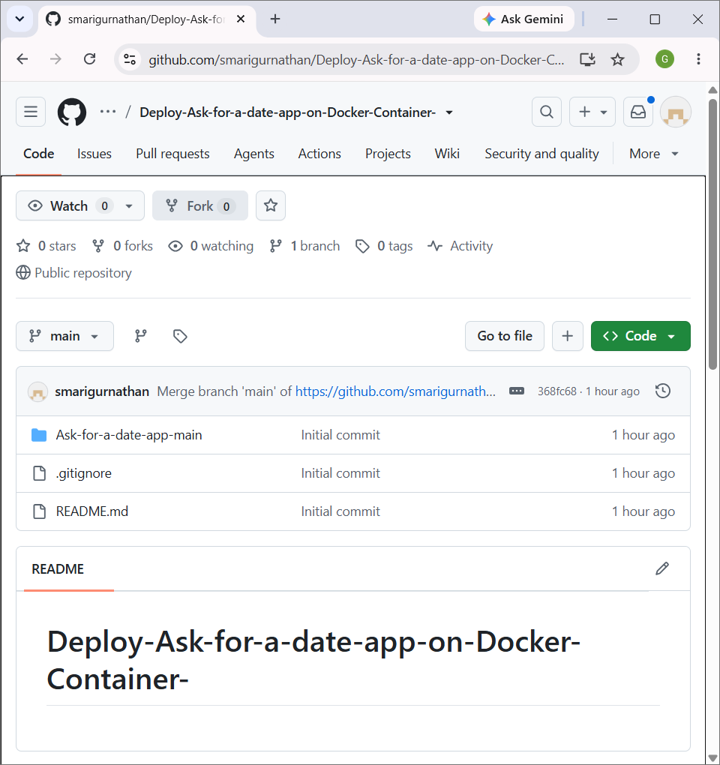
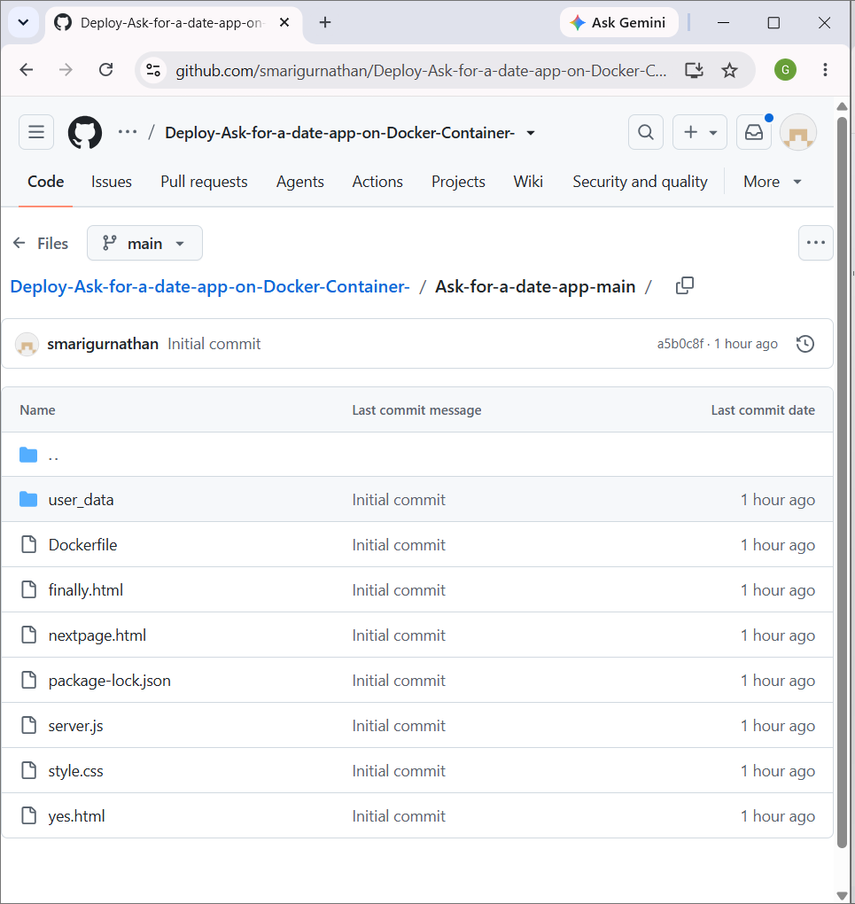

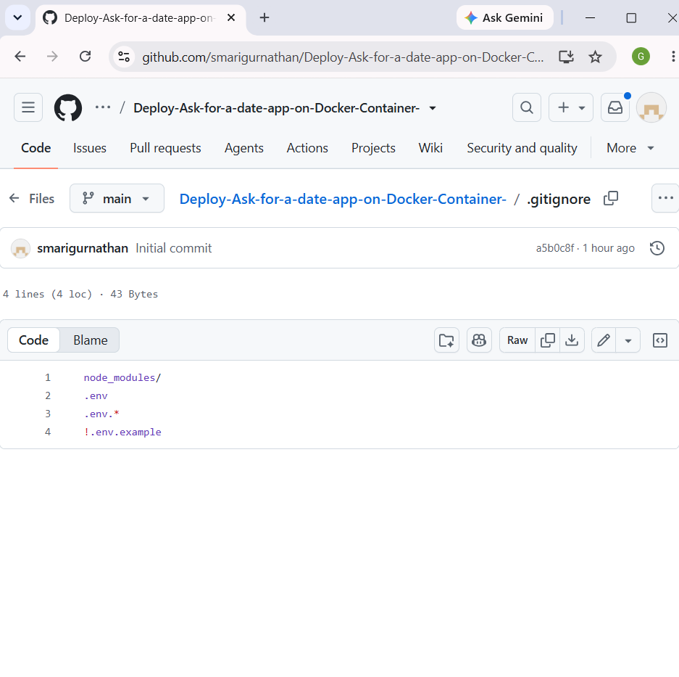

Date App on Docker

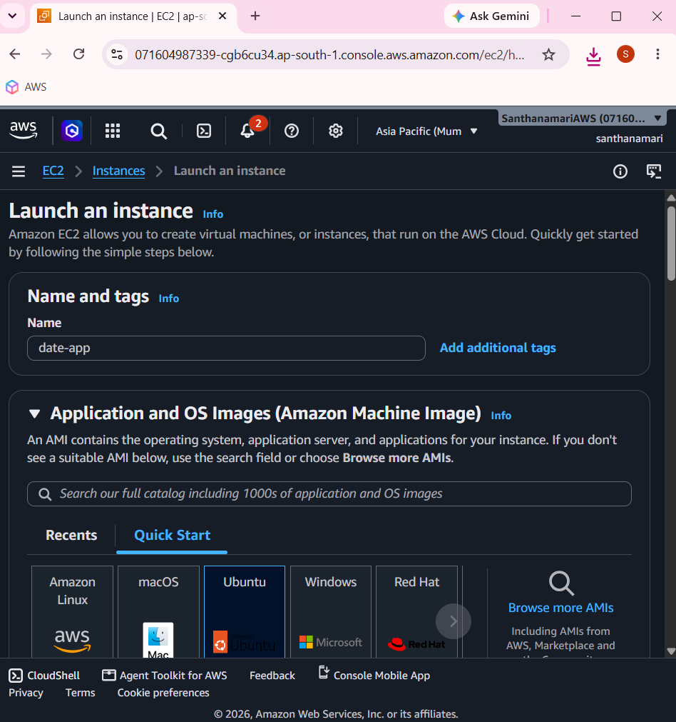

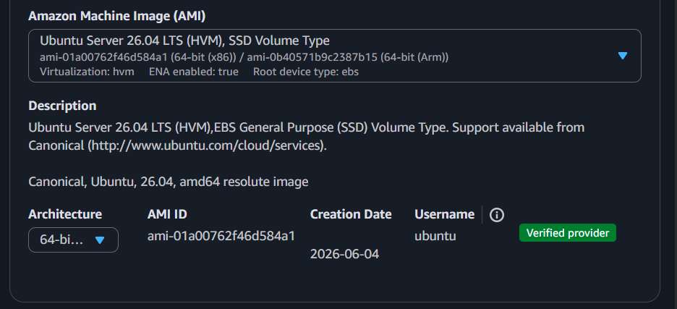

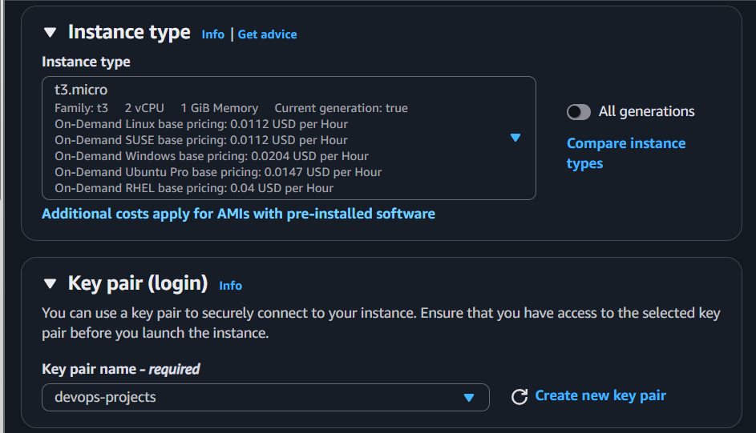

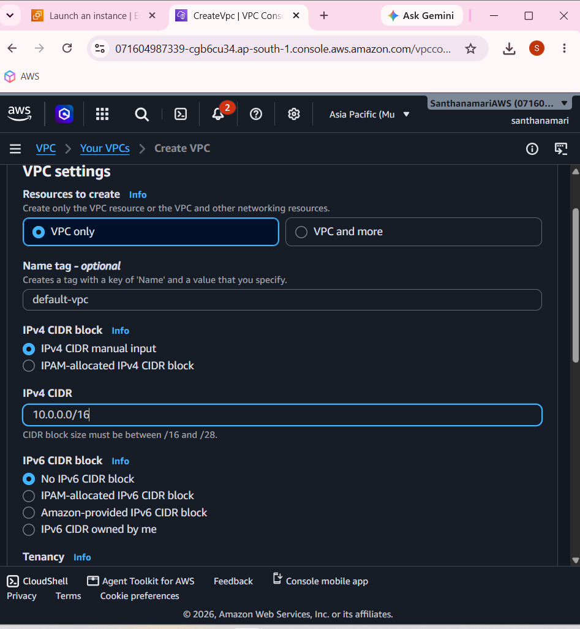

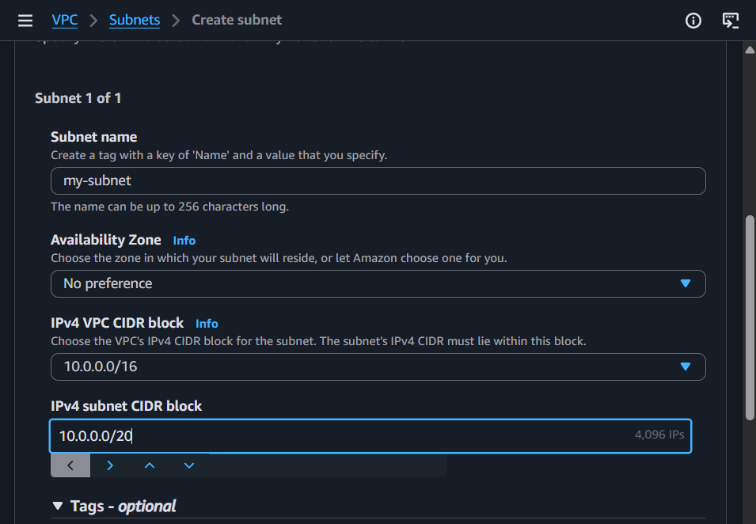

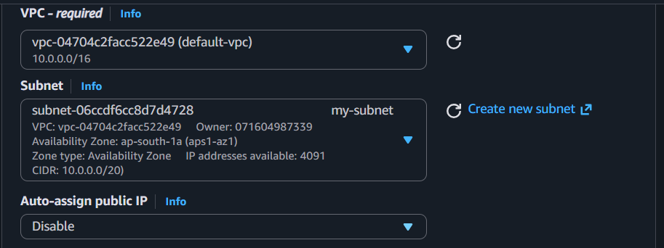

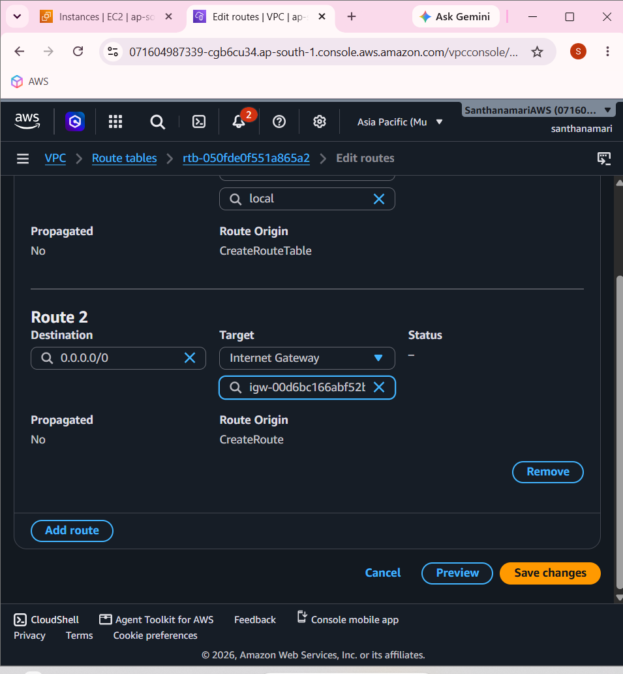
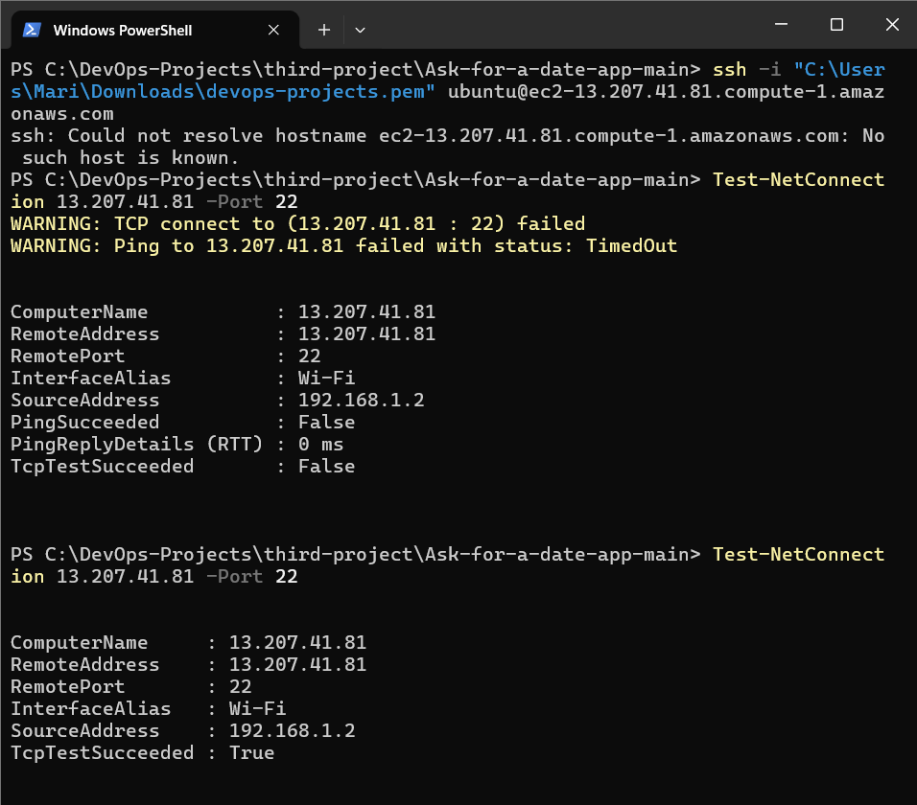

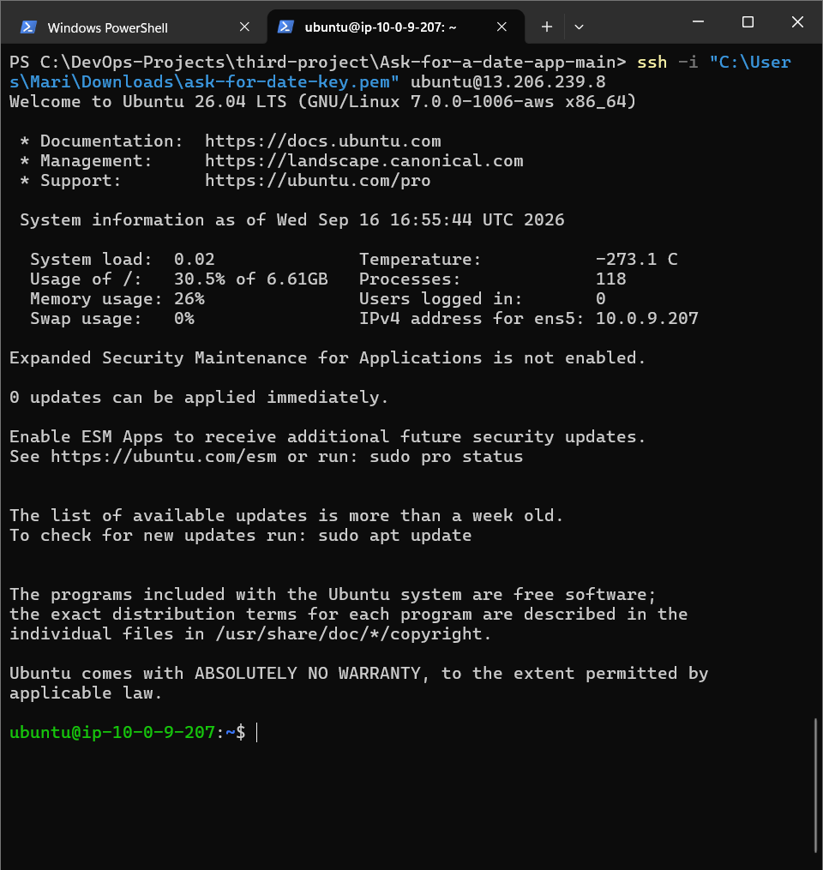

sudo apt update

sudo apt upgrade -y

sudo apt install git -y

git --version

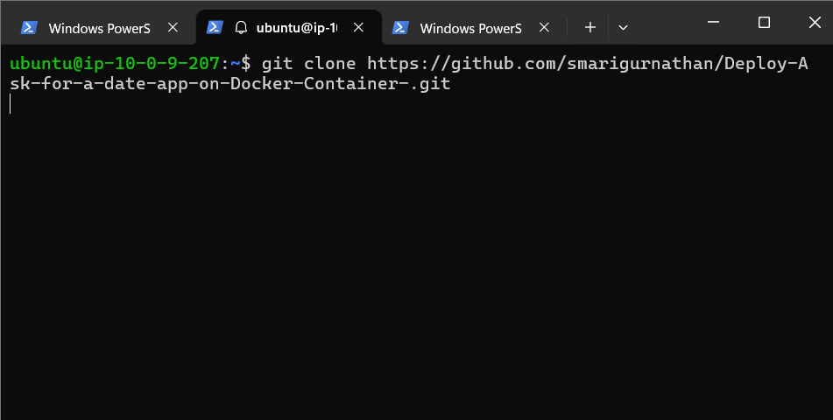
git clone https://github.com/smarigurnathan/Deploy-Ask-for-a-date-app-on-Docker-Container-.git

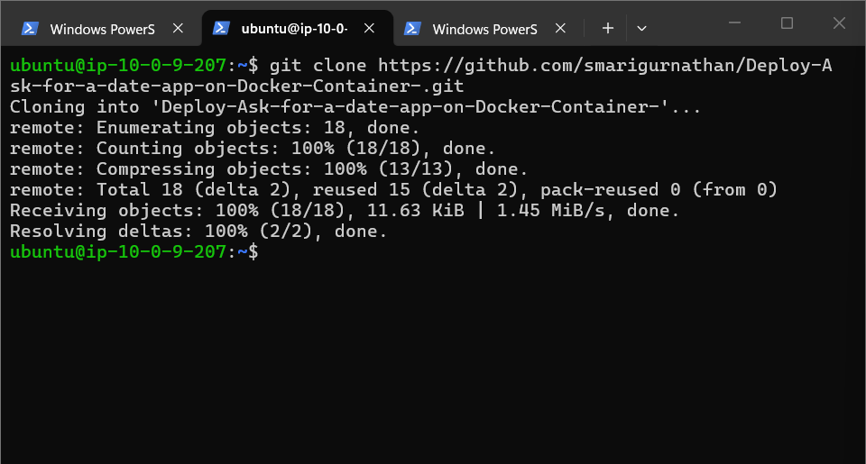

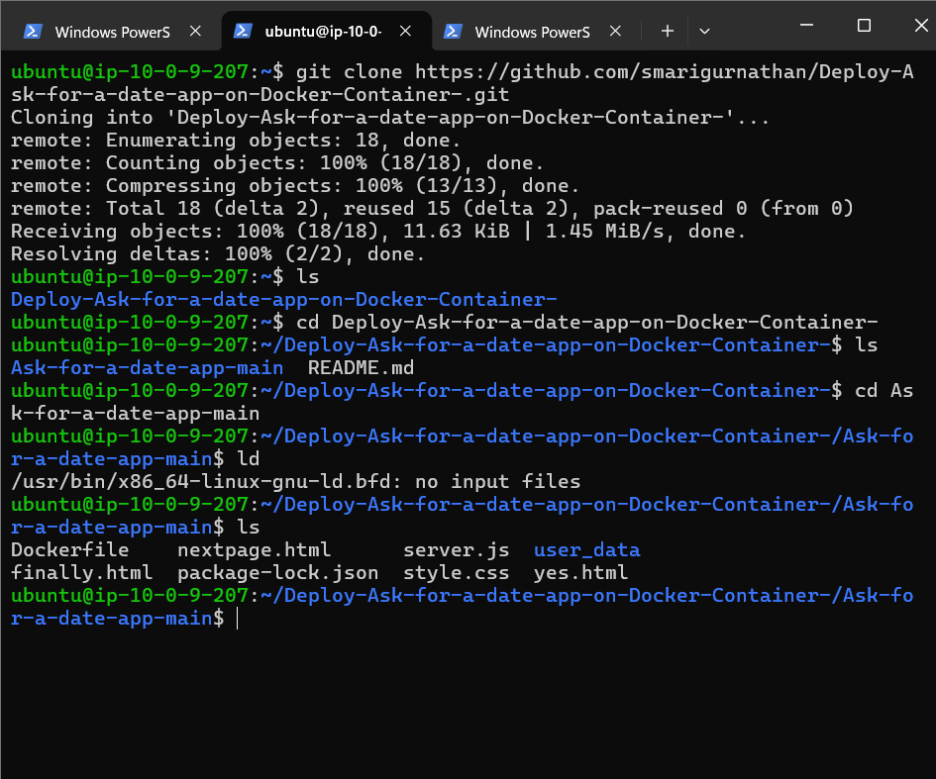

sudo apt install docker.io -y

docker --version

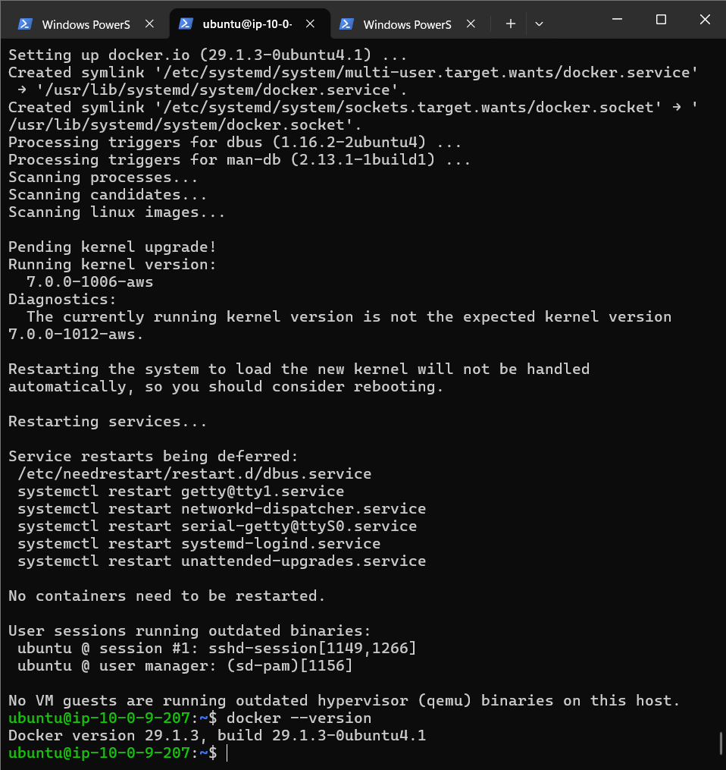

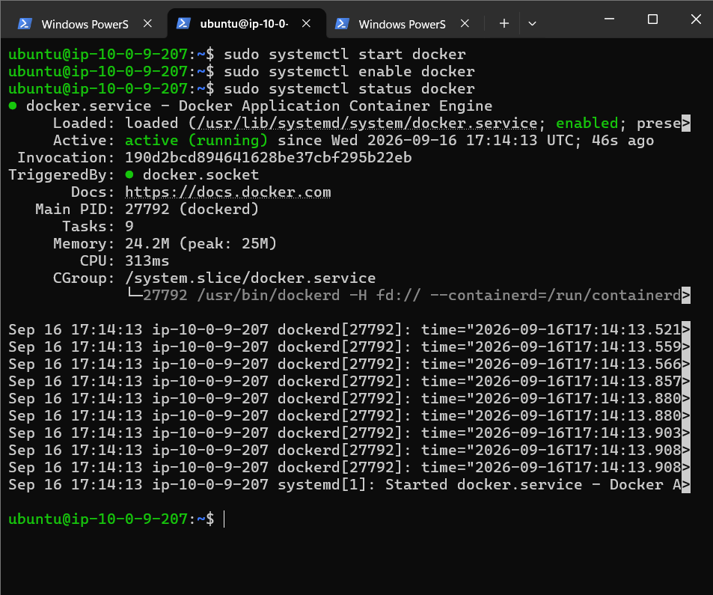

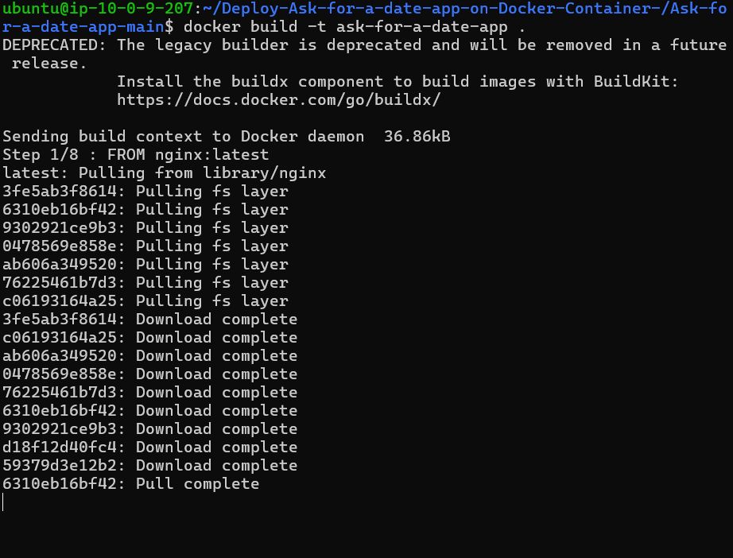

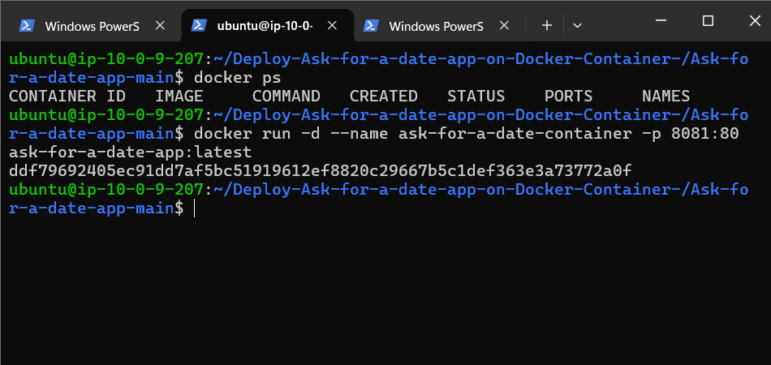

ddf79692405ec91dd7af5bc51919612ef8820c29667b5c1def363e3a73772a0f

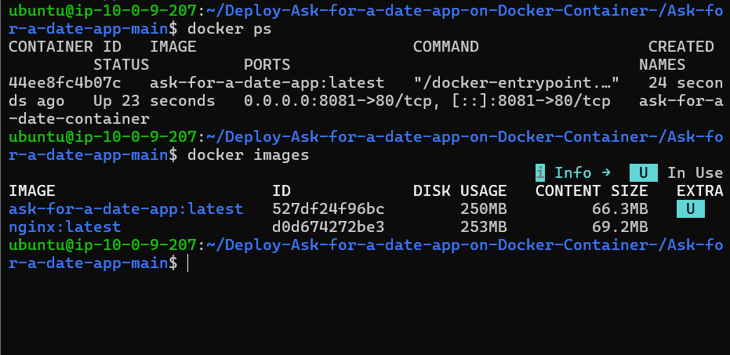

Result
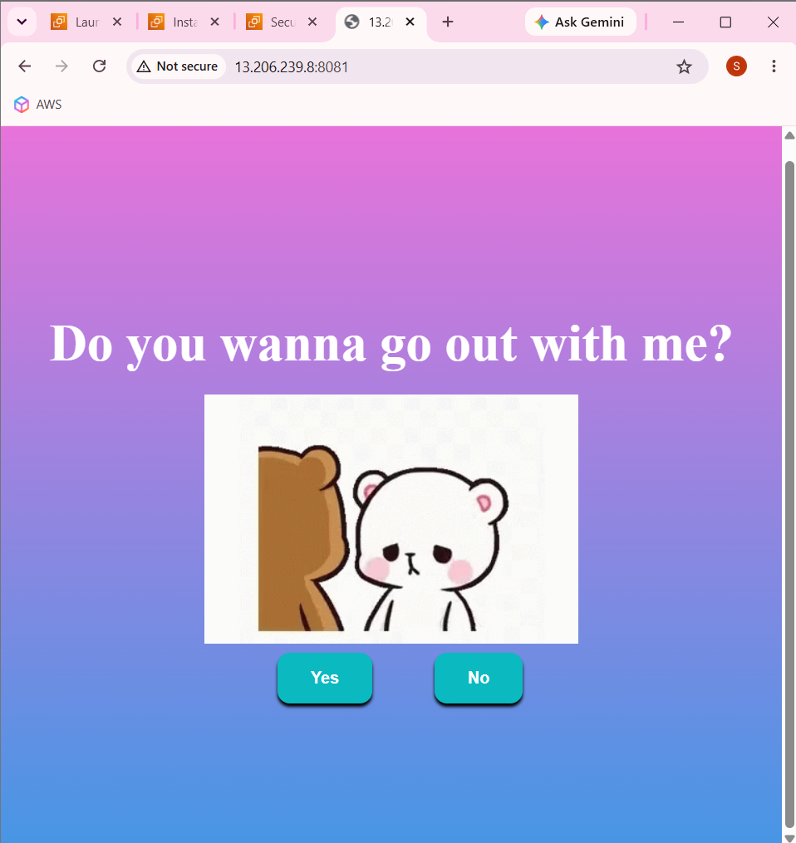

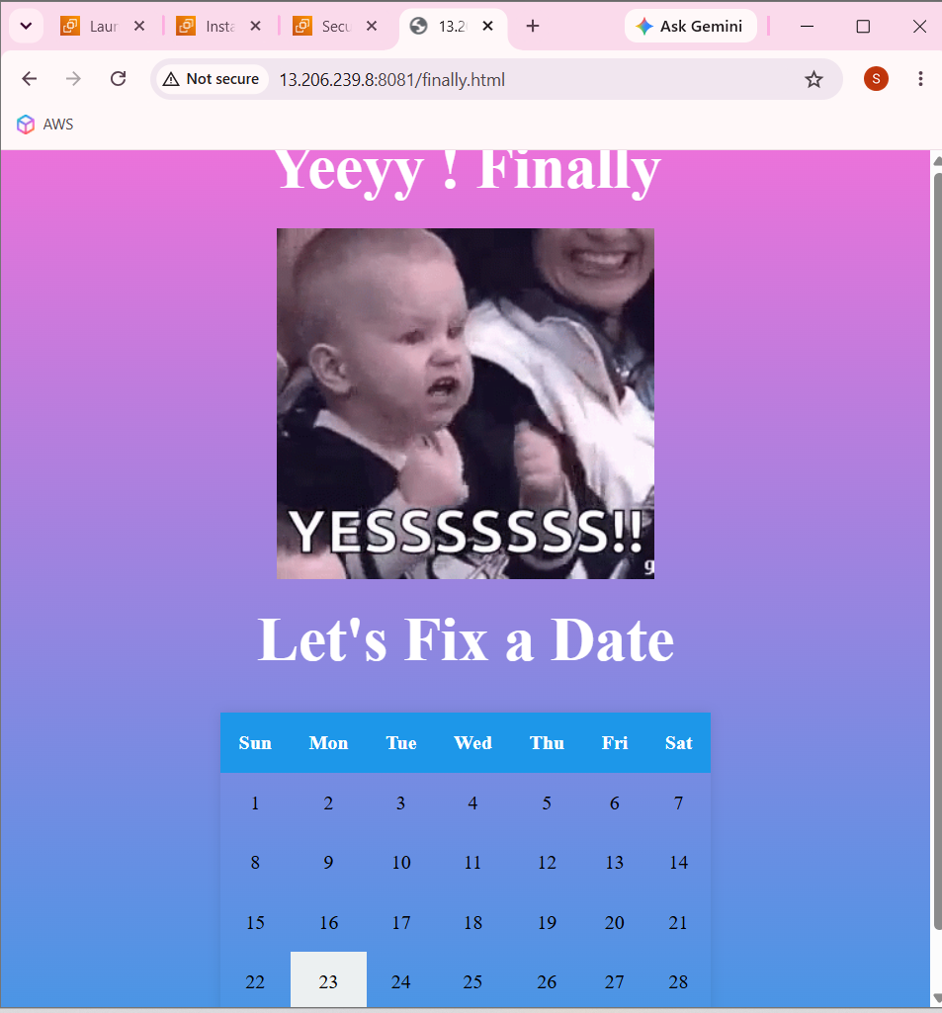

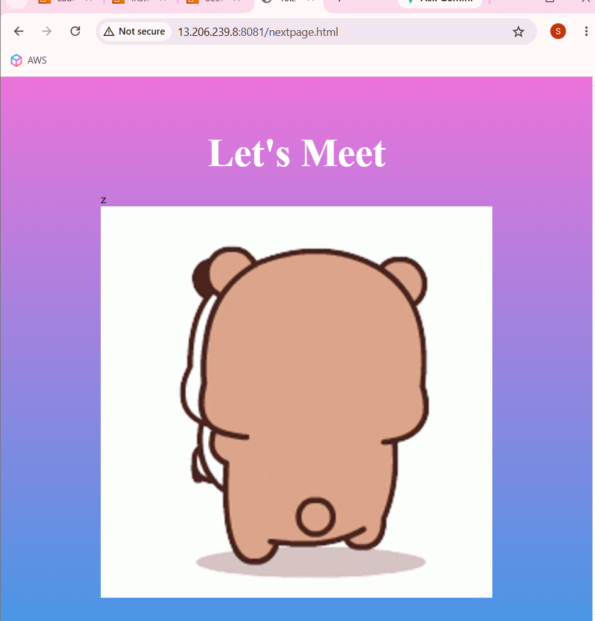

- First create all files inside vs code
- Second
  - docker --version
  - docker build -t my-dating-app .
  - docker images
  - docker run -d --name my-dating-app-container -p 8081:80 my-dating-app:latest
  - docker ps
  - http://localhost:8081
  - Get nginx page
- Create ec2 instance with ubuntu
- Ssh 22 my ip address and 8080 is custom tcp 8081 port number
- Then update ubuntu
  - sudo apt update
  - sudo apt upgrade -y
  - Then install git
  - sudo apt install git -y
  - git --version
  - Git clone https://github.com/smarigurnathan/Deploy-Ask-for-a-date-app-on-Docker-Container-.git

- Docker on EC2
  - sudo apt install docker.io -y
  - docker --version
  - sudo systemctl start docker
  - sudo systemctl enable docker
  - sudo systemctl status docker

- Give ubuntu user docker permission
  - sudo usermod -aG docker $USER
  - newgrp docker
  - docker ps
  - docker build -t my-dating-app .
  - docker images
  - docker run -d --name my-dating-app-container -p 8081:80 my-dating-app:latest

- http://13.206.239.8:8081/

Dockerfile

# Use the official Nginx image as base image
FROM nginx:latest

# Copy the HTML files to the Nginx default html directory
COPY finally.html /usr/share/nginx/html/
COPY yes.html /usr/share/nginx/html/
COPY nextpage.html /usr/share/nginx/html/
COPY style.css /usr/share/nginx/html/

# Expose port 80 for web traffic
EXPOSE 80

# Verify file permissions
RUN chmod 644 /usr/share/nginx/html/finally.html && \
chmod 644 /usr/share/nginx/html/yes.html && \
chmod 644 /usr/share/nginx/html/nextpage.html && \
chmod 644 /usr/share/nginx/html/style.css

# Start Nginx when the container launches
CMD ["nginx", "-g", "daemon off;"]

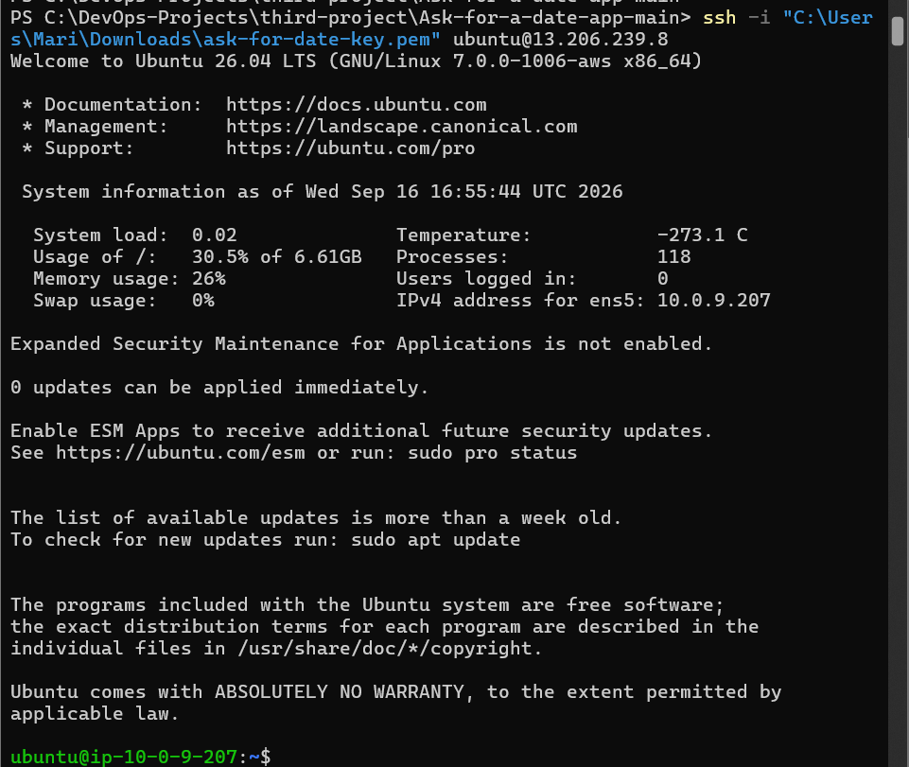

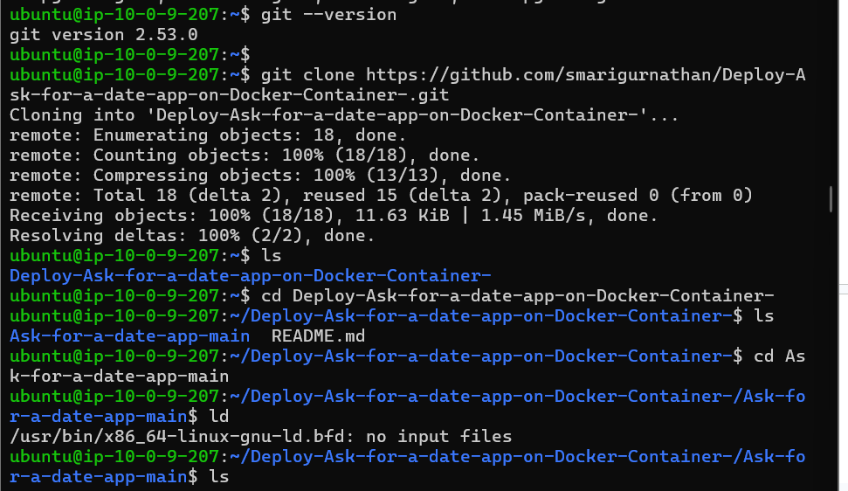

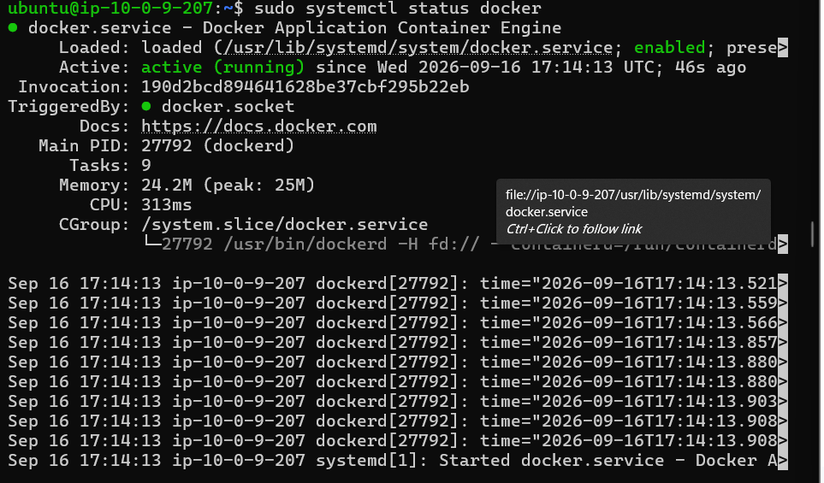

Docker is running





